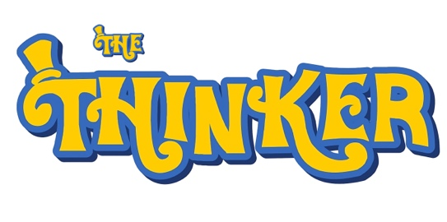
Dear Parent/Guardian,
I’m pleased to invite your child to join the Young Philosophers Training (YPT) enrichment programme for Years 4–6 at Greenbank Primary this half term (November–December). Sessions take place on Wednesdays, 3:15–4:15pm, starting 12th November running through to 10th December. .
Through discussion, games, and activities, pupils explore big questions about life, the universe, morality, society, art, and more - developing their thinking and communication skills in a fun, supportive environment.
Over three half terms, pupils work towards the Junior Young Philosophers Bronze Award, demonstrating growth in character, participation, communication, and presentation. Each child gives a short presentation on a topic of their choice to complete the award, before progressing to Silver and Gold levels.
You can find more information, photos, and video testimonials here:
https://thethinkerhub.com/young-philosophers-1
The cost for a half term of sessions is usually £45 (max 20 pupils) but for this introductory block the price is £40.
To book a place, please visit:
https://thethinkerhub.com/event-bookings/ola/services/greenbank-primary-philosophy-club-y4-6-november-2025
If you have any questions, please feel free to get in touch at glenn@thethinkerhub.com.
Best wishes,
Glenn Skelhorn
Director, The Thinker CIC / Royal Institute of Philosophy Tutor
www.thethinkerhub.com
1 Rose Lane, Mossley Hill, Liverpool L18 8ES
Company No: 14598944
