Address: Mossley Avenue, Liverpool, L18 1JB
Tel: 0151 522 5748
Email: greenbank-ao@greenbank.liverpool.sch.uk
Website: www.greenbank-primary.co.uk
Headteacher: Mrs D Wrigley

30th September 2026

Dear Parent and Carers

Join Sole Rebel dancers, musicians and Greenbank students for a special Jazz Tap Jam at Greenbank School, celebrating Black History Month and the rich history of tap dance as a Black American art form.

Come experience tap as music, learn more about its roots, watch some of our young dancers perform and enjoy an informal live jam with dancers and musicians.

Friday 9th October 4:00 – 5:30pm.
Tickets are donation-only and must be booked in advance via school to reserve your space.

Suggested donation: £5 per family (pay what you can). All donations will help us provide free places on Sole Rebel’s new after-school tap class, making the sessions accessible to more children and families.

Thank you
Greenbank Primary School
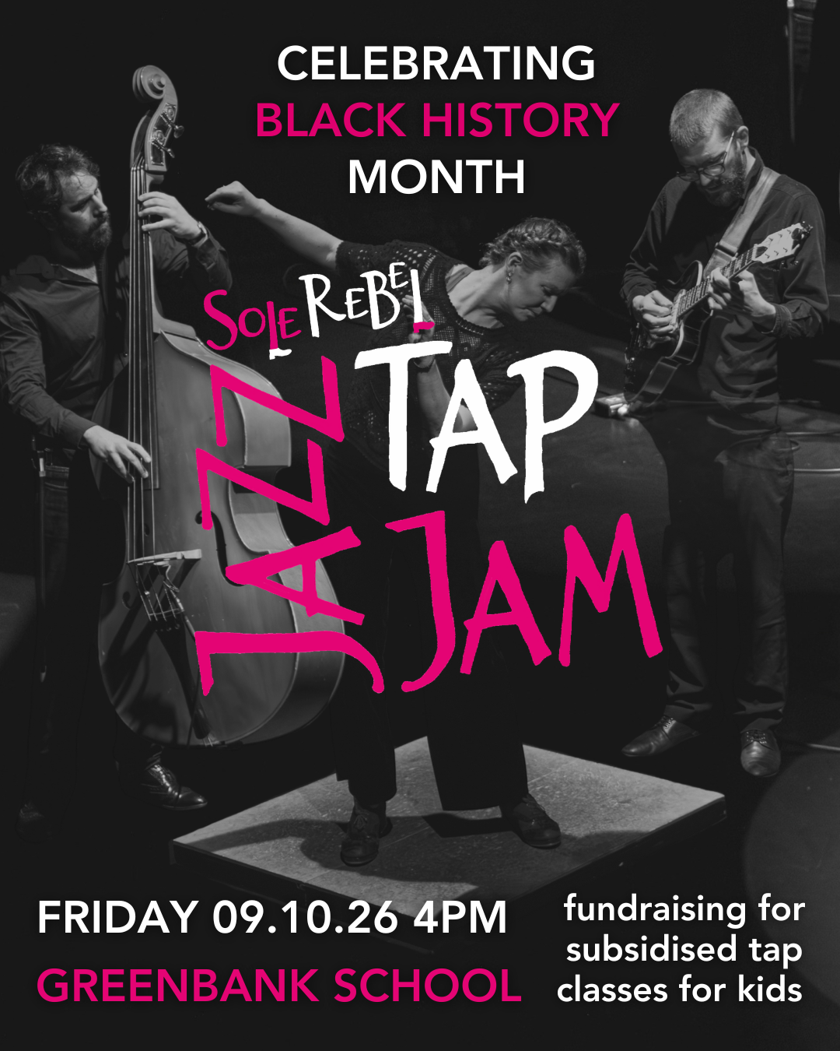
Sole Rebel

